1. 8 QUEEN’S PROBLEM

Aim:
To develop a Python program that solves the 8-Queen's Problem using the Backtracking Algorithm, ensuring that no two queens attack each other on an 8 × 8 chessboard.

Objective :
- To understand the concept of Backtracking.
- To place eight queens on an 8 × 8 chessboard.
- To ensure that no two queens share the same row, column, or diagonal.
- To generate one valid solution for the 8-Queen's problem.

Algorithm :
- Start.
- Create an empty 8 × 8 chessboard.
- Begin placing queens from the first column.
- For each row in the current column:
  - Check whether placing a queen is safe.
  - A position is safe if:
    - No queen exists in the same row.
    - No queen exists in the upper-left diagonal.
    - No queen exists in the lower-left diagonal.
- If the position is safe:
  - Place the queen.
  - Recursively place the queen in the next column.
- If all eight queens are placed:
  - Display the solution.
- If no safe position is available:
  - Remove the previously placed queen (Backtracking).
  - Try the next possible position.
- Repeat until a solution is found.
- Stop.

Flowchart :

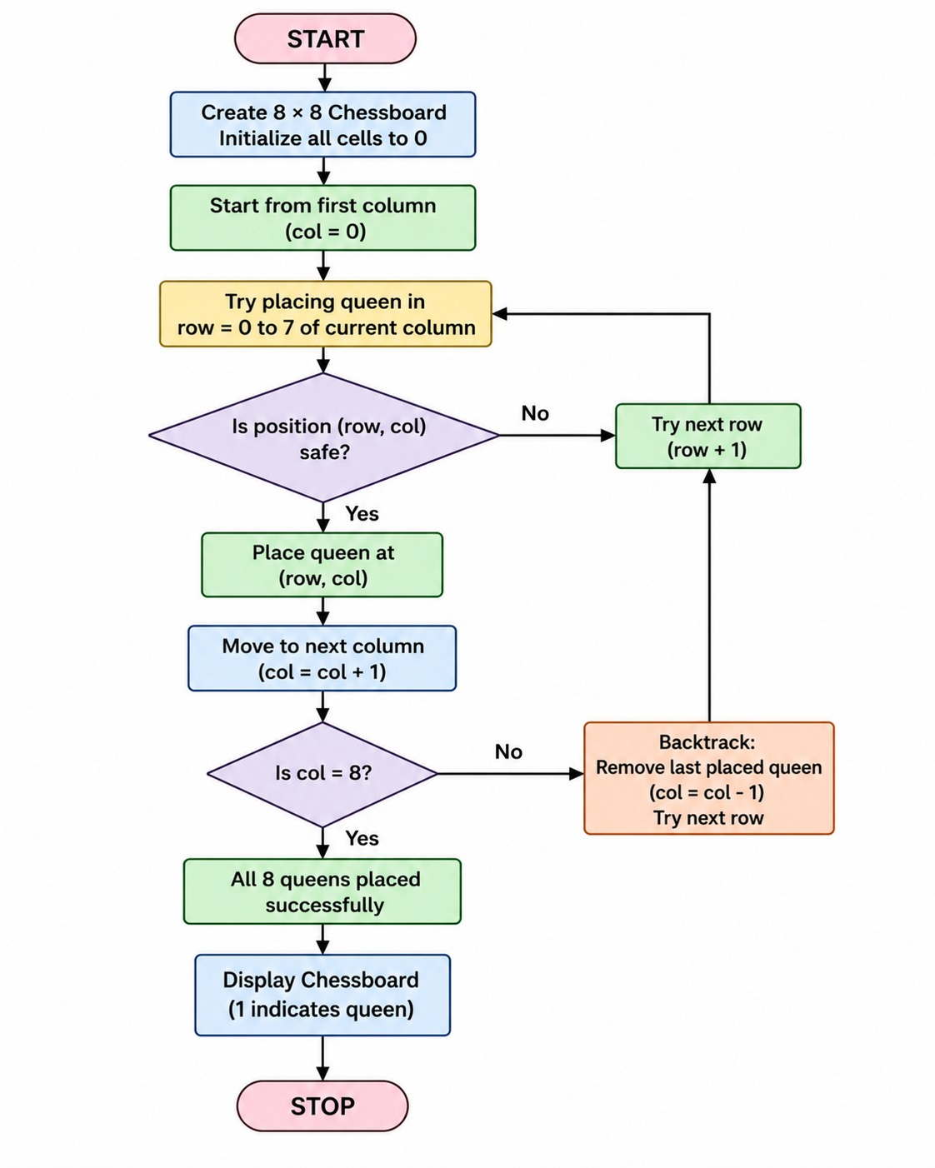

Code:
N = 8
x = [-1] * N
def safe(row, col):
for i in range(row):
if x[i] == col or abs(x[i] - col) == abs(i - row):
return False
return True
def queen(row):
if row == N:
return True
for col in range(N):
if safe(row, col):
x[row] = col
if queen(row + 1):
return True
return False
if queen(0):
print("Solution:")
for i in range(N):
for j in range(N):
if x[i] == j:
print(1, end=" ")
else:
print(0, end=" ")
print()
else:
print("No solution")

Output:

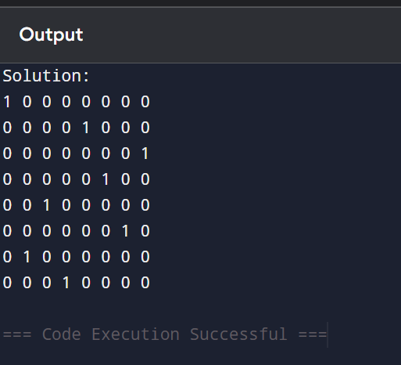

Result :
The Python program was successfully implemented using the Backtracking Algorithm to solve the 8-Queen's Problem. A valid arrangement of eight queens was obtained such that no two queens attack each other horizontally, vertically, or diagonally.

